**Final Report Fall 2022**

GT Campus Equity and Sustainability Tours Sub-Team

VIP Building for Equity and Sustainability

Shasha Liu, Weiting Huang, Julia Park, Tri Le, and Minjun Seo

**Contents:**

Introduction p.2- 3

1. Goals

Summary p.4- 8

1. Campus Equity and Sustainability Tour
2. Tour Feedback

Sites Research p.9- 19

1. Definition
2. Sites

Research Resources _p.20- 23

1. United Nations’ Sustainable Development Goals
2. OxFam Donut

Reaching Out p.24- 27

1. Kendeda Poster Fair
2. Survey

Conclusion p.28- 32

References p.33

**Introduction**

Our team is the "Georgia Tech Campus Equity and Sustainability Tour" for the "Equity and Sustainability VIP'' course at the Georgia Institute of Technology. This team developed in the Fall of 2022, and we continue to develop material from the previous semester. Our team comprises five members: Shasha Liu, Julia Park, Tri Le, Weiting Huang, and Minjun Seo. We are all new to this VIP, and our team has no returning members this semester. With little guidance in comparison to the other groups, we’ve worked hard to establish leadership in our sub-group and learn about sustainability, equity, and inclusion. The team wanted to be a part of this sub-team, as it was the most computer science-oriented group, as we could integrate technology into tours. However, we should also consider that the main purpose of our team is to create and develop sustainability-related tours, not to be computer-science-focused. This purpose closely aligns with our academic and professional goals as computer science majors, as we feel that learning about equity and sustainability is crucial to building a welcoming, supporting work environment in the future.

## 1) Goals

We have a few goals for this project:

1. We want to review and make changes to the existing guide that Miguel and Lauren developed based on the review responses from Spring 2022. We also want to emphasize that the tours will center around equity and sustainability.
2. We want to build our understanding of what equity and sustainability are and how it can relate to our tours group.
3. We want to use the resources provided by Jenny such as the United Nations’ Sustainable Development Goals and the Oxfam Donut, to build our understanding of equity and sustainability.
4. We want to have research related to equity and sustainability, especially focusing on our perspective on Georgia Tech’s campus. We want to add 1-3 sites for the tour that allows us to delve deeper and give a “why” on how that site is related to equity and sustainability.

As stated earlier, since this team is still developing from last semester's work, most of the work for this midterm deliverable will be a case study, planings, and reaching out to potential organizations. By the end of this semester, we plan to complete our goals by making a process for reaching out to different organizations. We also plan to finalize which case study is best for the tour and reach out to the potential partner(s) that could help us develop the VR/virtual self-guided tour.

**Summary**

Here is information and data we observed from the previous documents and work that Miguel and Lauren developed last year. Below are our thoughts about what they did well, what we could improve on, and next steps. We analyzed the Campus Equity and Sustainability Tour powerpoint and feedback from surveys.

## 1) Campus Equity and Social Sustainability Tour

Tour-guide ([Campus Equity and Social Sustainability Tour.pptx](https://drive.google.com/open?id=17sR4zNwhliUKZfD39MMojb612mQ-7sp9)):

The "land acknowledgment" part is essential but often neglected when considering equity and sustainability. The guide was packed with information like the detail of each location and visuals and was well organized. It will allow the reader to form a verbal and visual connection to these sites on tour. "I like how in-depth details of every place mentioned are provided with historical context, increasing understanding of the place and Atlanta. Even with the positive changes highlighted, I appreciate that the slides still brought up concerns as a way to maximize positive effects rather than just minimize the harm" (Weiting).

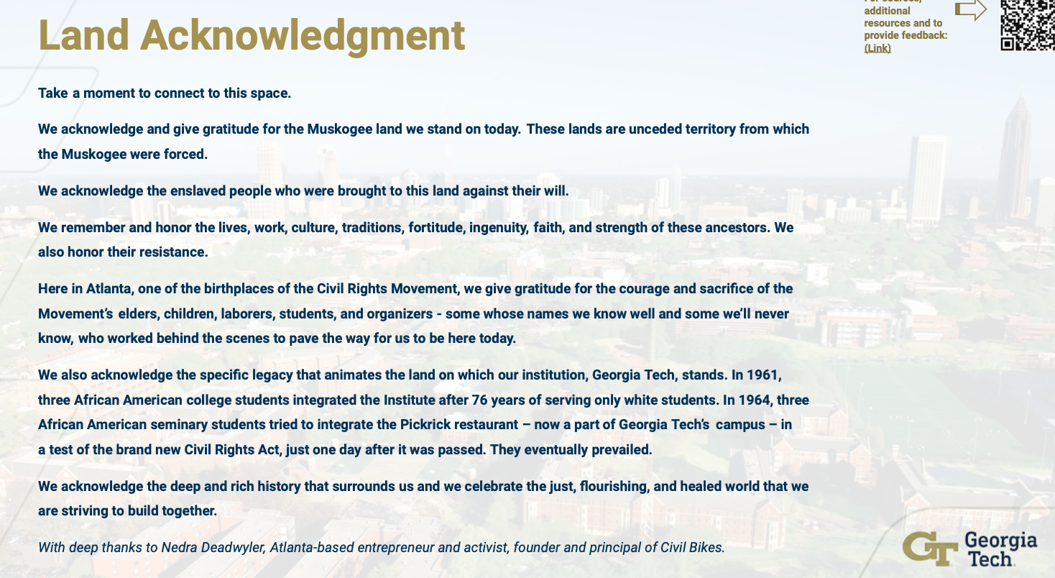

However, because of the important, meaningful information on each site. It does seem like the guide was "too packed with images and small font texts." The layout of the images and texts confused the readers and made them difficult to follow. Too much text makes it easy to lose focus of what is the most important takeaway.

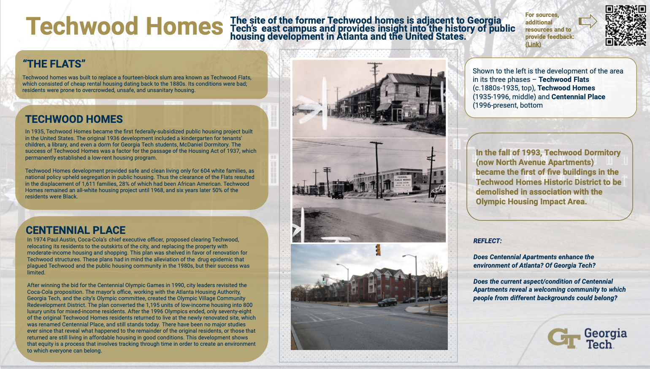

In the future, we would like to add more visuals and "cut down" on the number of texts. Using bolding or italicizing keywords can improve readability and memorability. The following steps for this semester could be to gather more information and the history of other races like Hispanics and Asians (for example, the history of Delta Phi Lambda). More information on disability services provides on-campus and accessibility. We should also include information about the green technology/ Work Green use at Georgia Tech.

## 2) Tour Feedback

[Tour Feedback](https://drive.google.com/open?id=1YZFGdBDTll16ElO2JvIrR1KHlS3ZwyyoxPs1It81c9A):

The data from the survey was precise about what the intent was and what had been done already. It helped us reflect on what to improve and work on. It is good to back up improvements in sustainability and equity with quantifiable results. Also, the mention of income equality is great because that is something we haven’t thought about or discussed.

Some improvements from feedback from the survey are essential:

* Including the flag building in the tour would be a good idea. The building shows flags of nations of many Georgia Tech students, and it might make some visitors feel welcome. The office of the LGBTQIA Resources Center is also located there.
* Some tour participants didn’t see how the tour was related to sustainability. We could improve the tour by continually emphasizing equity and sustainability, as that is the central focus of the tour.
* Research on the history of how Georgia Tech is involved in "equity and sustainability," and somehow make sure the "audience" knows and understands that it relates to sustainability and equity. For instance, "income inequality at Georgia Tech." It would be essential to explain how equity is related to sustainability and explore the income inequality here on campus. It would also be crucial to consider how this conversation may make some feel defensive and uncomfortable and spark further conversation this way.

The feedback mentioned that specific Black female graduates from Georgia Tech were not mentioned. Our team wants to work on this and proceed with these next steps:

* Do more research on why some of the first Black students didn’t know each other nor finish their degree here at Tech. Although the tour did emphasize the statue of Rosa Parks, it would be beneficial for the tour to showcase Georgia Tech graduates who are Black women.
* Make sure that we can provide the audience through the guide with the knowledge they want to hear about equity and sustainability without making them feel overwhelmed by a large chunk of facts, history, and information.
* We can also "spark conversation" during the tour with question prompts about how minority groups can now connect on campus through clubs and OMED.

**Sites Research**

Before looking at the sites that we researched on and selected as our new tour stop locations, we want to ask you a question: Do you think that all the sites on Georgia Tech campus are inclusive and make everyone feel welcomed, and do these sites fall under sustainability principles?

We want to ask you this question because we wanted to raise a concern here, about how Georgia Tech is lacking in equity and sustainability. As we went in depth with several sites on the Georgia Tech campus, we noticed issues with inclusivity. We found out that although the campus is located in the center of Atlanta, a place housing diverse residents and many visitors across the world, the Georgia Tech campus being a major symbol of Midtown Atlanta fails to adapt to the diversity it is located in. For example, the campus is constantly patrolled by the GTPD police force and the campus feels like a cocoon only for students. Therefore, it was challenging for us to find sites on the campus that fall under both equity and sustainability. However, we were able to select a few that adhered to a specialized perspective of sustainability and equity although we also recognize their flaws. Before looking at the sites that we researched, we will include a definition of sustainability and equity.

Definition:

* Sustainability:
* Sustainability consists of fulfilling the needs of current generations without compromising the needs of future generations, while ensuring a balance between economic growth, environmental care and social well-being.
* Our most basic requirements: non-polluted air, clean water and fresh food are all essential parts of the environment, as is the energy and raw materials we need for construction and transportation. Environmental sustainability is essential if we wish to have and continue to have the resources to meet our needs. In the broadest sense of the definition, environmental sustainability involves the entire global ecosystem (oceans, freshwater systems, land and atmosphere). However, environmental sustainability principles can equally be applied to ecosystems of any size, even down to the scale of a small home garden.
* A socially sustainable society is one in which all members have equal rights, all share equitably in societal benefits, and all participate equally in the decision-making process. Additionally, a society is unsustainable if it consumes resources faster than they can be renewed naturally, discharges more waste than natural systems can assimilate without degrading, or depends upon distant sources for its most basic requirements. As with environmental sustainability, social sustainability principles can be applied to societies of any size. For example, one of sustainability’s grand challenges is to simultaneously reduce consumption in the developed world while raising the standard of living of the developing world – we need to be responsible global citizens by making informed choices every day within our homes and communities.
* Equity:
* The word equity is defined as “the quality of being fair or impartial; fairness; impartiality” or “something that is fair and just.” Equity is more complicated than equality.
* The complication with equity is that people often disagree on what is “just” or “fair.” These are subjective concepts and, as a result, laws and policies that attempt to achieve equity are often challenged in court or are controversial.
* The use of the word equity has increased due to concerns about social justice and a desire for fairness for historically oppressed groups. By law, minority groups may have equal rights but are still treated unfairly in real life. Therefore there is increased awareness on how people may have subconscious bias and microaggression.
* Historically oppressed groups such as LGBTQ+ group and People of Color have not only fought for equality, but continue to fight for equity in society.

***Sites:***

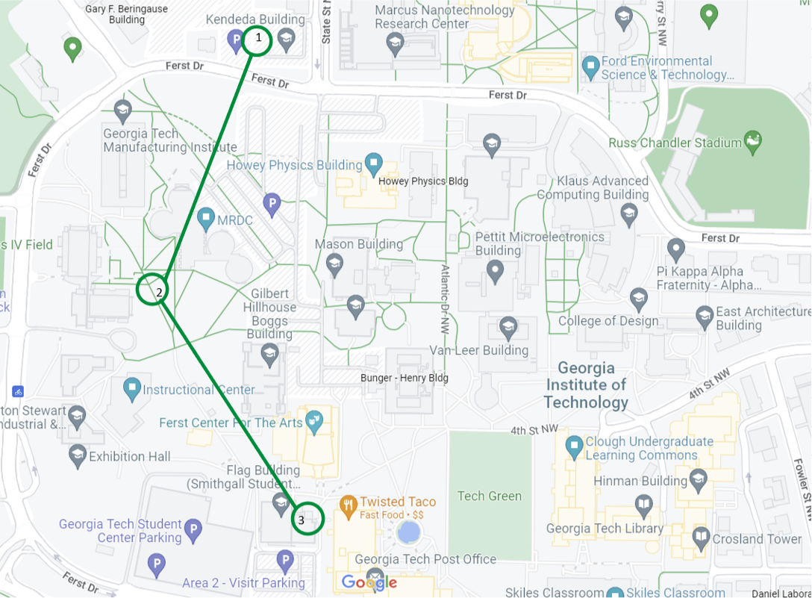

Map of the sites

1) Kendeda Building and EcoCommons

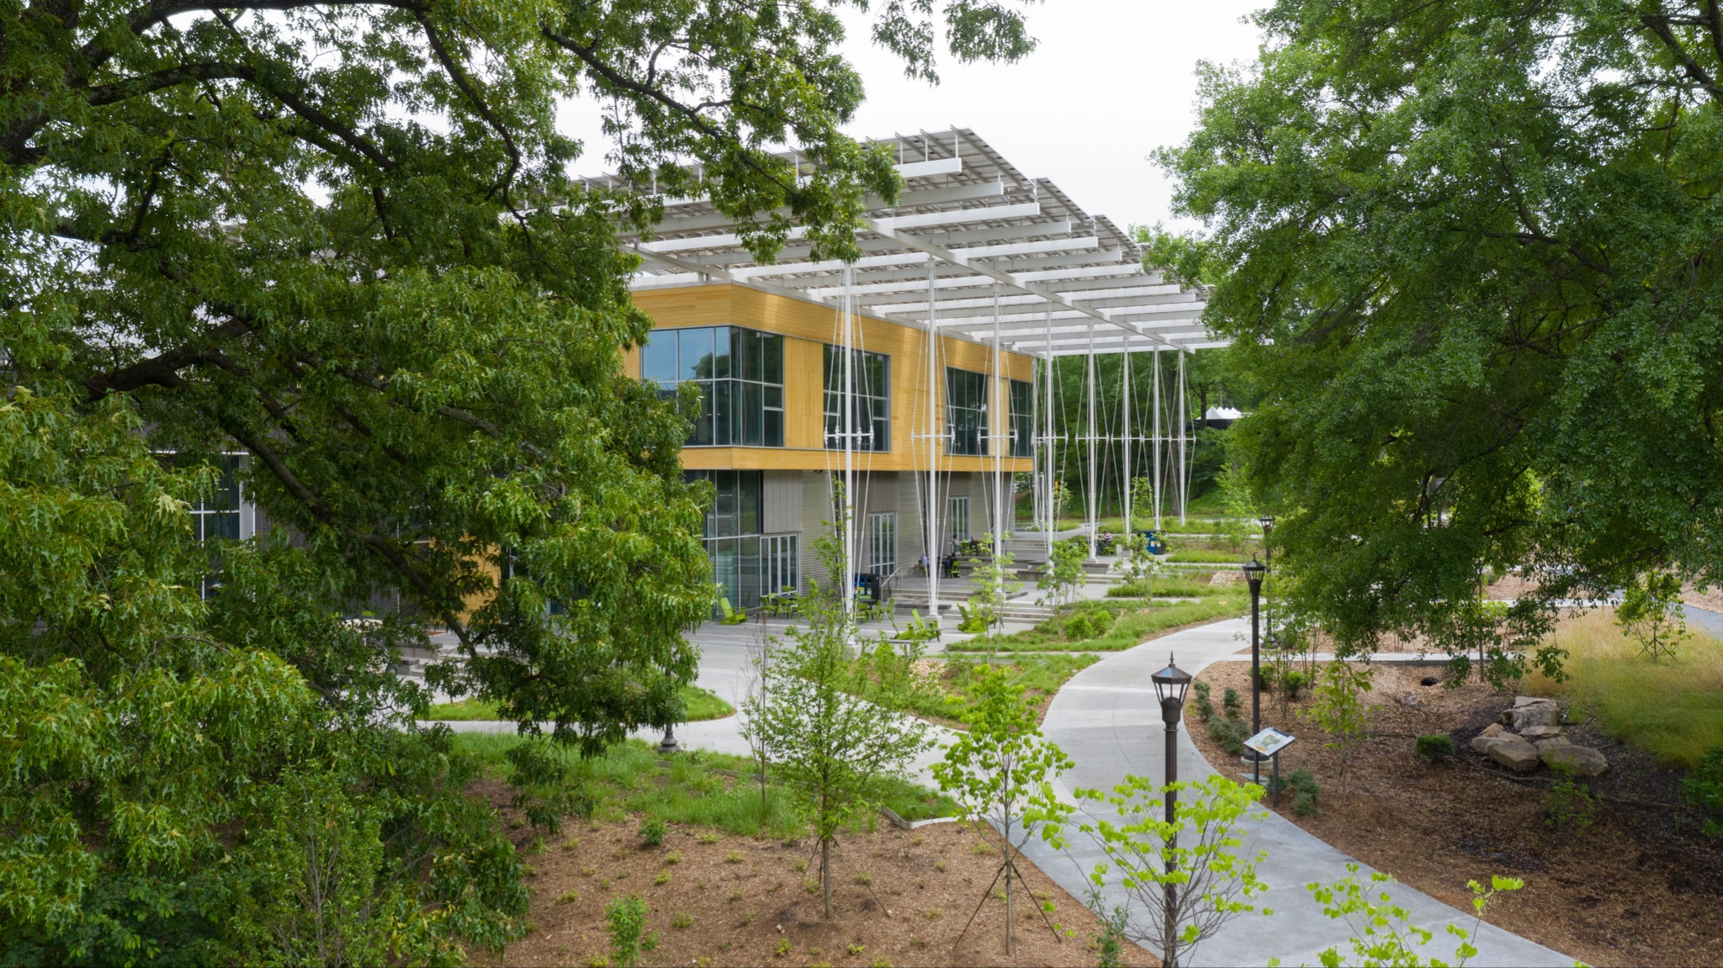

Outside of Kendeda Building and EcoCommons

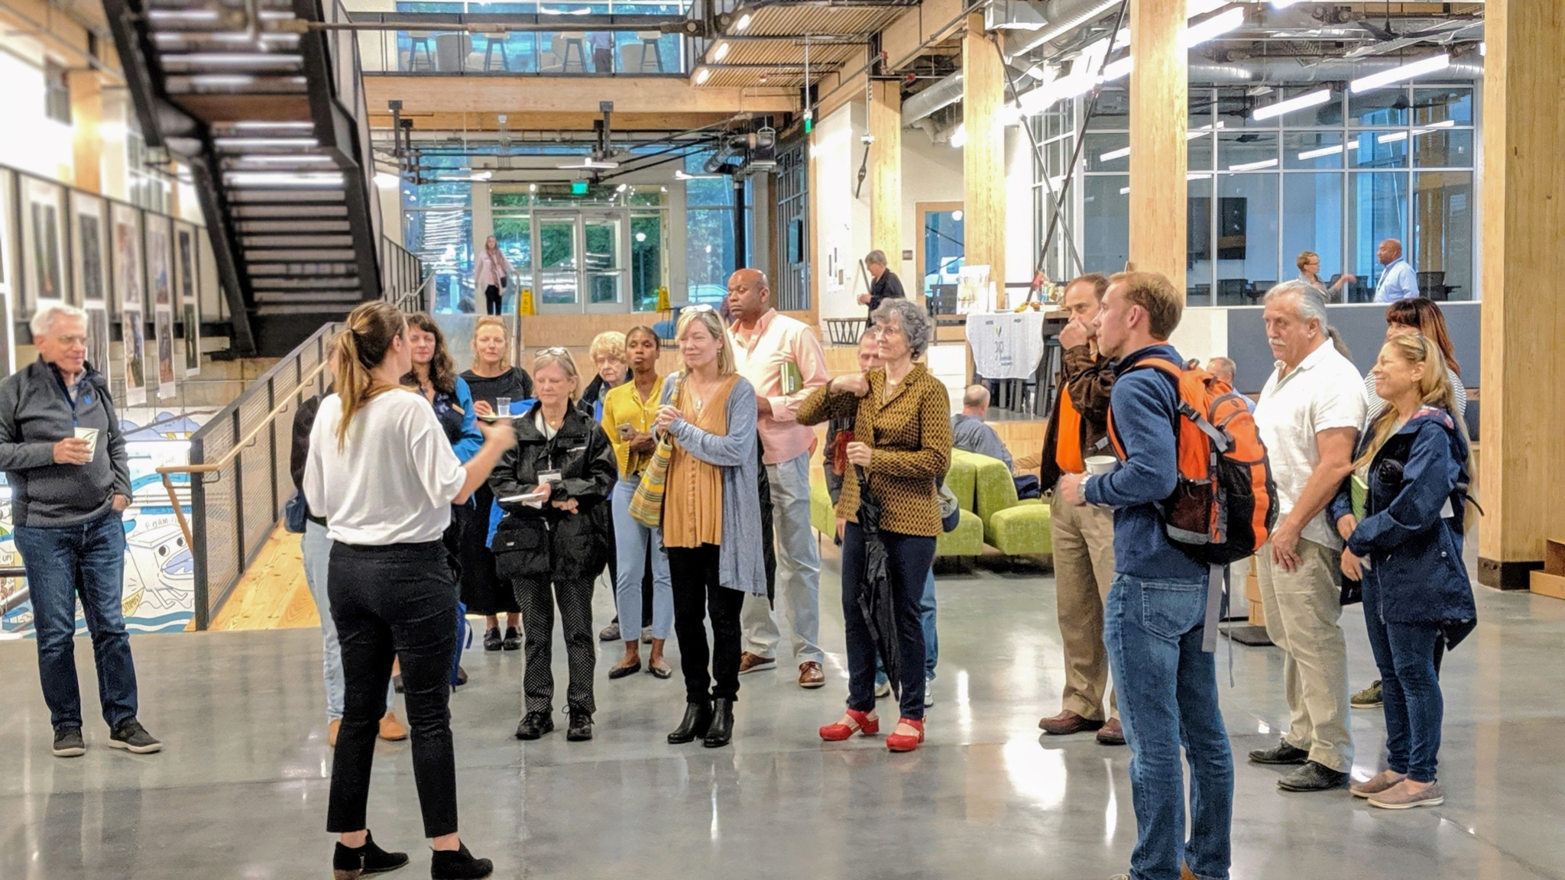

Kendeda Building with people

* The Kendeda Building received the Living Building Challenge certification which proves its purpose to push the boundaries of sustainable design -> not just reduce harm but to maximize positive impacts.
* From its 7 sustainability pedals, the equity pedal specifically serves to transform how design can improve the greater community of life and our cultural fabric. Therefore, the connection between
* The Eco-Commons serve as a living laboratory for people to interact with and understand natural ecology, which evolves to support biodiversity.

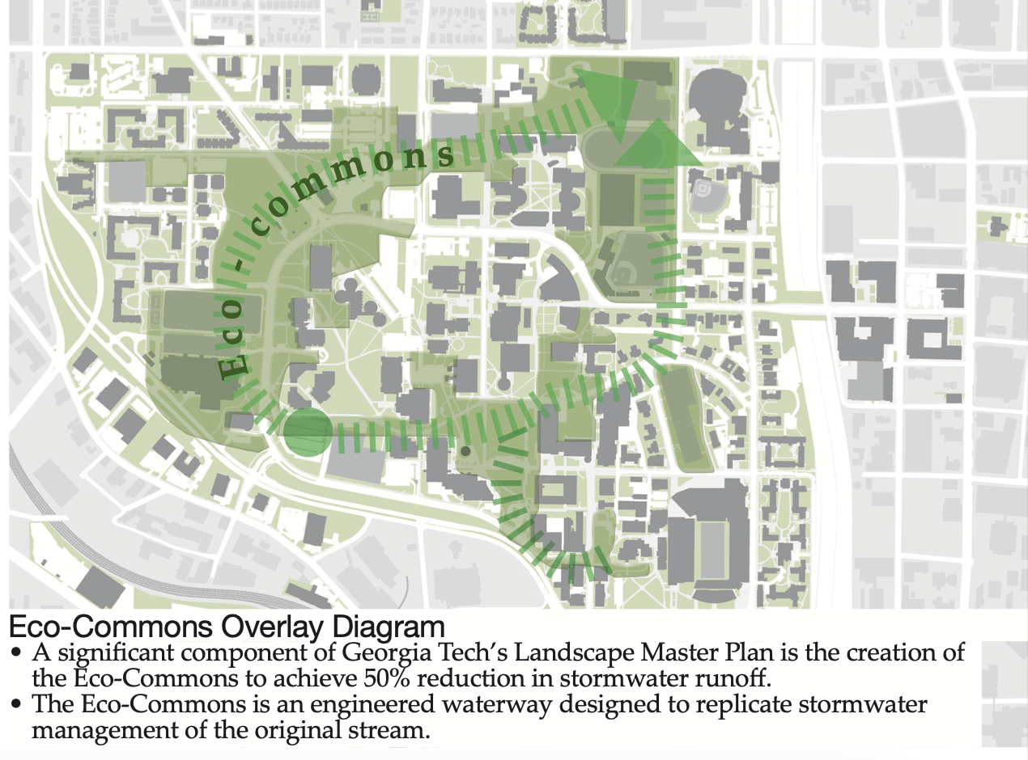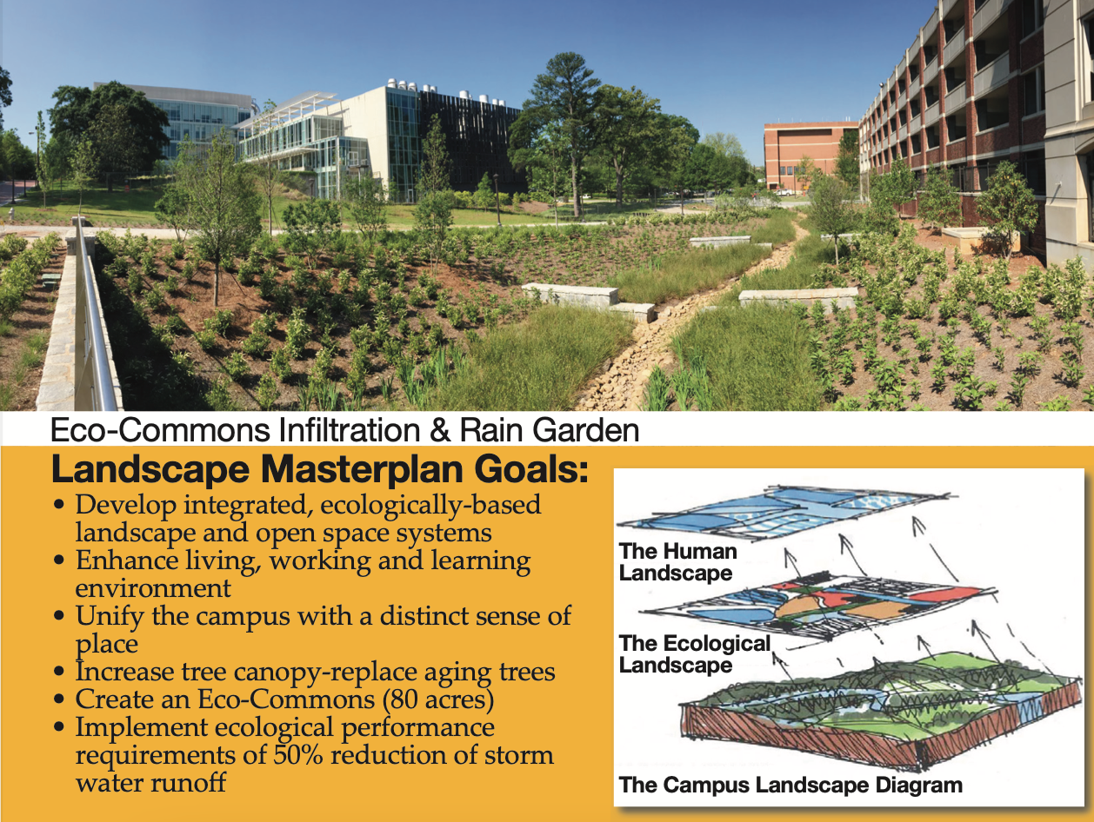

EcoCommons and Biodiversity

* Despite the Kendeda building’s purpose to maximize its positive impacts, there are still issues with inclusivity. For example, the menstrual products are only located in the women’s restroom and are labeled as “feminine products,” thus failing to consider transgendered and nonbinary people.
* On Georgia Tech’s building websites, the Kendeda Building website is introduced as “By raising the bar for building performance, we are encouraging Georgia Tech to keep reaching higher. We want students and faculty to embrace the challenge, continually asking ‘How can we improve on this?’” With the building being closed on the weekend, which makes it not fully accessible for students nor faculty. Additionally, being closed on weekends makes it difficult for visitors and the communities around Georgia tech to come and learn about the building. Therefore, improvements can be made to have Kendeda be a safe place for access at all times to improve inclusivity and accessibility for equity.

2) Olympic Sites

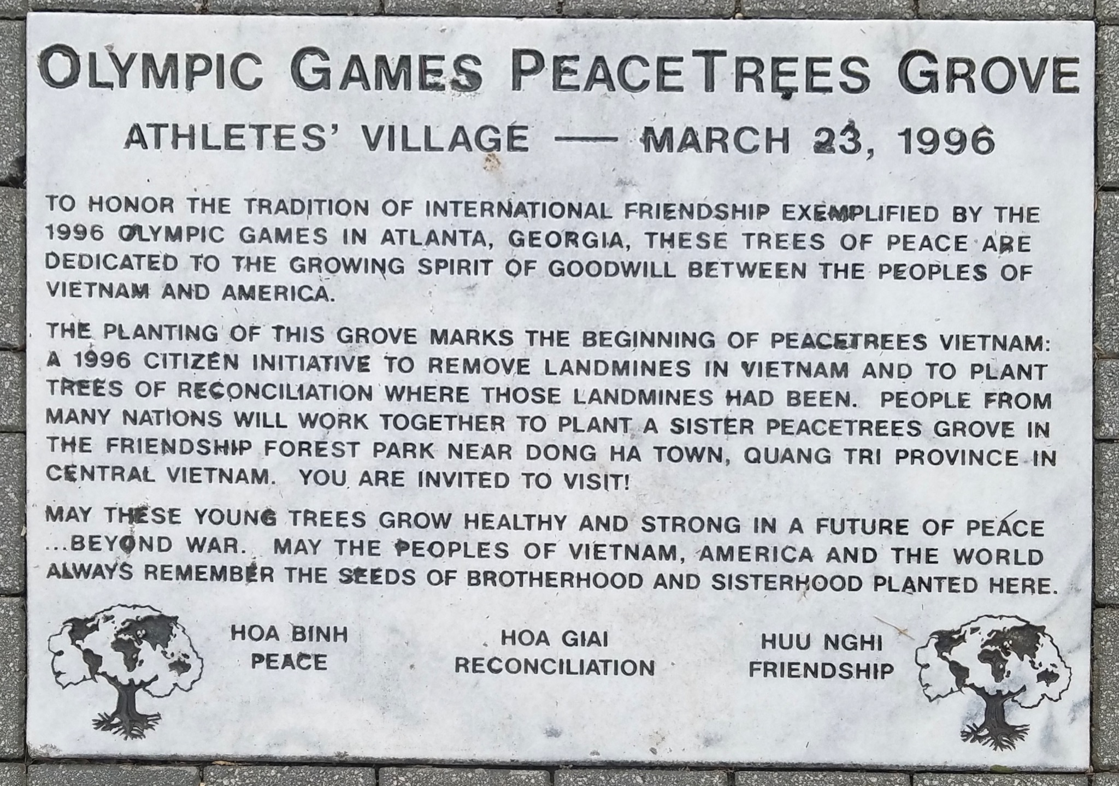

Olympic Games PeaceTrees Grove Sign

[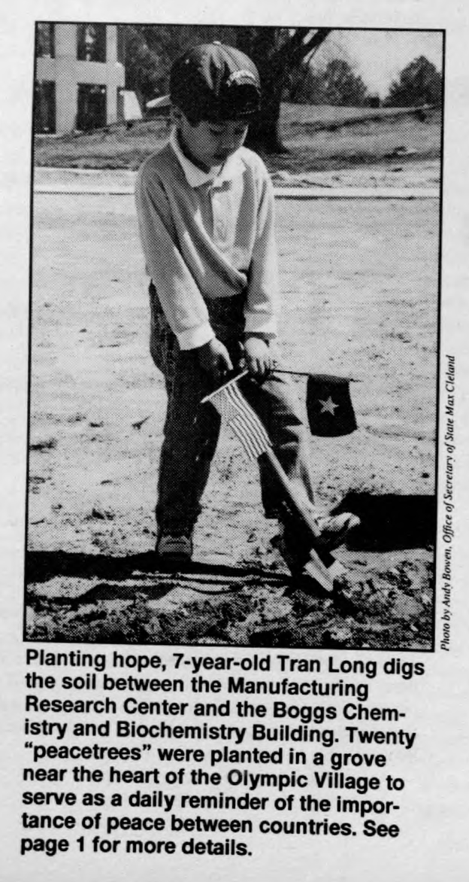](https://smartech.gatech.edu/bitstream/handle/1853/41536/1996-04-01_19_80.pdf?sequence=1)

* The sign was installed on March 23, 1996.
* The sign was installed as part of the athletes’ village (Olympic Village) for the Olympic Games in 1996.
* Although the Olympic game brought much economic activity to Georgia, the state government forced out the homeless to make room for building new facilities and accommodations, thus accelerating the process of social and economic divide in Atlanta. From a sustainability perspective however, the buildings from that era are still in use today such as the Olympic pool becoming a part of Georgia Tech’s campus and the Athletes’ housing becoming the North Avenue apartments for GT students.

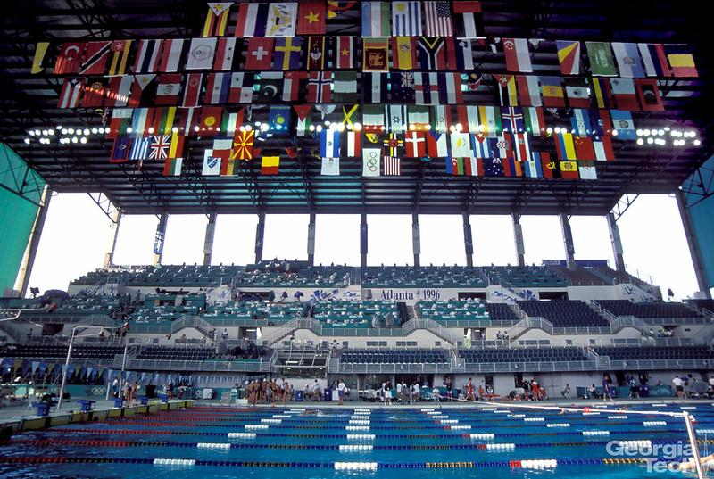

Olympic Pool

3) Charles A. Smithgall

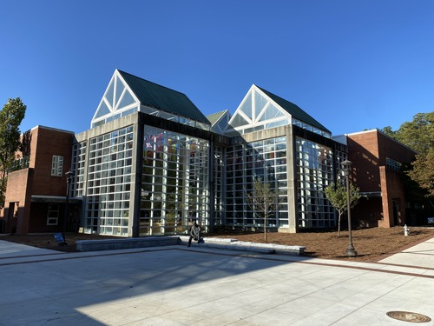

Outside of Smithgall Building

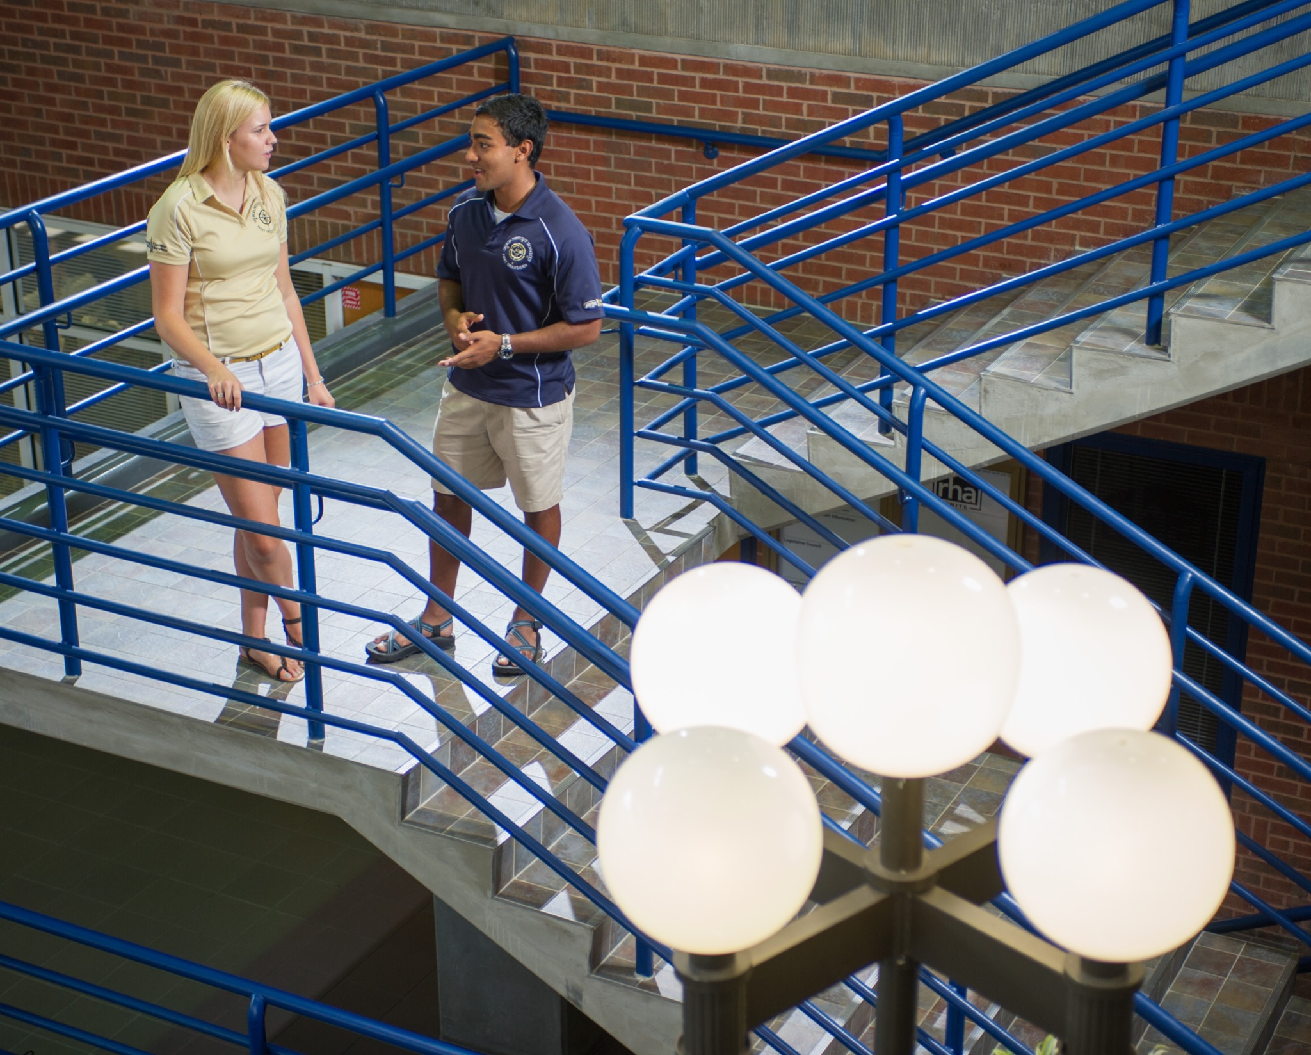

People inside Smithgall Building

* Nicknamed the “Flag Building.”
* One hundred twenty-four flags hang in the Atrium to represent at least one currently enrolled Georgia Tech student from that country.
* The building provides offices for Students' Temporary Assistance & Resources (STAR), Office of Disability Services, Women's Resource Center, Student Media, Student Organization Finance Office (SOFO), Residence Hall Association (RHA), Division of Student Life, Student Government Association, Parent & Family Programs, Campus Services, Office of the Arts, Counseling Center, Testing Center, CARE, Office of the Dean, and LGBTQIA resource center.
* The Flag building fails to be transparent about how often the flags are updated, more specifically whether the flags get updated every-year when a student of a new country of origin enrolls. Additionally, the building does not include any specific resources it has for international students who are from these different origins. Thus, a question is raised on whether the signature flags of the Flag building are mainly for performance.

**Research Resources:**

**United Nations’ Sustainable Development Goals:**

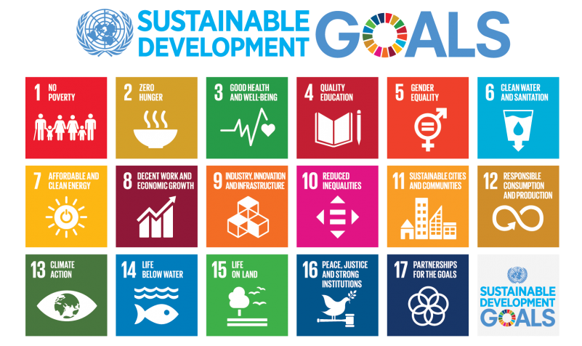

The United Nations Sustainable Development Goals (SDGs) are a set of 17 global goals adopted by the UN in 2015. The goals are intended to be a blueprint for a better and more sustainable future for all, with the aim of ending poverty, protecting the planet, and ensuring that all people have the opportunity to live peaceful and prosperous lives. The SDGs include goals such as ensuring access to quality education and healthcare, promoting gender equality, and taking urgent action to combat climate change. The goals are interconnected and are intended to be achieved by 2030 through partnerships between governments, civil society, and the private sector.

The SDGs are important because they provide a common framework for addressing some of the world's most pressing challenges. By setting specific, measurable targets for improving conditions in areas like health, education, and economic development, the SDGs aim to guide countries and organizations in their efforts to create a more sustainable and equitable world.

In addition, the SDGs are important because they are inclusive and equitable. They recognize that sustainable development must be achieved for all people, regardless of their gender, race, age, or other factors. The SDGs therefore seek to ensure that no one is left behind, and that all people have the opportunity to live healthy, prosperous lives.

Overall, the UN Sustainable Development Goals are an important global effort to address some of the most pressing issues of our time. By providing a common framework and goals, they aim to foster collaboration and cooperation, and to create a more sustainable and equitable world for all.

**OxFam Donut:**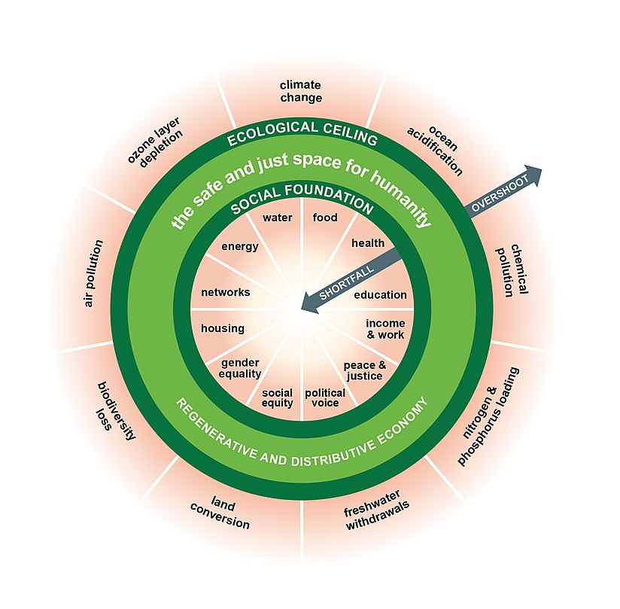

The doughnut economic model is based on the idea that there is a "safe and just space" for human development that exists between two "limits": the social foundation, which represents the minimum levels of social and environmental well-being that must be met for all people, and the ecological ceiling, which represents the maximum levels of environmental pressure that the planet can sustain. The goal of the doughnut economic model is to guide economic policy and decision-making in a way that ensures that all people can meet the social foundation and that environmental pressures remain within the ecological ceiling.

Oxfam, the global organization that works to end poverty and inequality, has adopted the doughnut economic model as part of its work. In 2017, Oxfam published a report called "The Economy for the 99%," which used the doughnut economic model to analyze the distribution of wealth and income in the United Kingdom. The report found that the UK economy was not meeting the needs of the majority of its citizens, and it called for policies that would help to create a more inclusive and sustainable economy.

In summary, the doughnut economic model is a framework for understanding the relationships between social and environmental well-being, and for guiding economic policy and decision-making in a way that promotes both. Oxfam has adopted this model as part of its work to create a more equitable and sustainable world.

**Reaching Out**

1. Introduction:

We wanted to make sure we gain a full perspective on equity and sustainability not only on websites, documents, and articles, but also with human interactions. More specifically, our subteam wanted to understand the perspective of other people on Georgia Tech’s campus on equity and sustainability. A way we did this was through the Kendeda Poster Fair that was held on December 1, 2022. Minjun and Julia were both present throughout the entire hour and got feedback from different VIP instructors and students at Georgia Tech.

1. Feedback we Received:

As we had interesting conversations and dialogues on equity and sustainability, we got some feedback that will be useful to our subteam for the next semester. For example, one student inquired whether our sites for the tour considered the furniture inside the buildings or sites. This was a perspective we did not think about and will consider in the future. An instructor also asked how we decided what sites to include, if we had a quantifiable metric. We considered this into our research and realized that most of our evidence was anecdotal and we might need more convincing evidence to our audience for the tour on why we included this site into the tour.

Jenny also mentioned that the pictures we used on the poster didn’t include many people. She gave us feedback by stating that next time, we should have people in our pictures, emphasizing on the point that they should also include a diverse range of people, such as People of Color. Next time we have a presentation, we will make sure to include pictures of diverse people instead of pictures of the sites. For example, instead of putting a picture of the flag building’s flags, we could put a picture of people interacting within the flag building.

1. Survey:

Our subteam included a survey for the people who attended the poster fair. We presented this in a QR code and had several people scan it. However, we received no responses. The questions we asked in the survey are as follows:

1. **Kendeda Building and EcoCommons**

Is the Kendeda building and Eco-Commons accessible or welcoming to not just Georgia Tech but the Greater Atlanta community?

1. **Kendeda Building and EcoCommons**

What is the role of these places and their design in furthering equity in our environment?

1. **Olympic Games PeaceTrees Grove Sign**

Have you known about this site?

1. **Olympic Games PeaceTrees Grove Sign**

Does this site deserve to be known more?

1. **Olympic Games PeaceTrees Grove Sign**

Do you believe this site is accessible to everyone?

1. **Charles A. Smithgall**

This site is the best fit for equity, but how about sustainability?

1. **Charles A. Smithgall**

Do you think this building shares the idea of a “socially sustainable society,” where everyone has equal rights and all share equitably in societal benefits?

We want to evaluate why we received no responses, as having data is crucial to analyzing results and to form a conclusion. We looked at research articles to discern why our survey was not effective.

According to the Pew Research Center, one reason as to why we did not receive as many survey responses as expected is due to the format of our questions. People are more inclined to answer questions that require smaller amounts of effort. This would include multiple choice and true or false formatted questions. However, our survey was largely free response. In the future, we will consider using mostly multiple choice style questions with few possible choices. In doing so, the survey as a while will be perceived as less of a hassle.

Furthermore, the Pew Research Center suggests strategizing the order in which the questions are asked. The context created by previous questions can influence the types of responses in following questions. As in this case, it is possible that the first question asked deterred participants from continuing on to the following questions. This effect can be mitigated if the order of the questions were randomized and distinct for each survey.

Based on our research regarding effective surveying for data, we plan to implement the following in the future: make surveys multiple choice, randomize order of questions.

**Conclusion**

The work we have for this midterm deliverable might seem "broad" at this point. Still, the team thinks that all the information we have collected above is essential to help us achieve our goals by the final deliverable. We all believe by the final deliverable, we will be able to reach out to all the organizations and have a better scope of our work in terms of equity and sustainability. We would be able to finish developing a newly developing tour guide, in terms of what information and sites we must include in the tour. We hope that we will be able to have another tour based on the new tour guide and get the final thought and input from the participants. Because we think that would help our team to have a "perfect" guide by Earth Day 2023 (the "launching day" for the tour to the public), we hope we will get more participants through the tour promotion.

To better understand what the participants wanted to see from the tour, we have put up a small survey that included three questions for the participants during the class campus tour on September 9, 2022. And here are the responses we got from the participants. We think that it is essential that we include this in the midterm deliverable, so the team can further look back on these inputs from the participant and improve the tour experience based on these inputs.

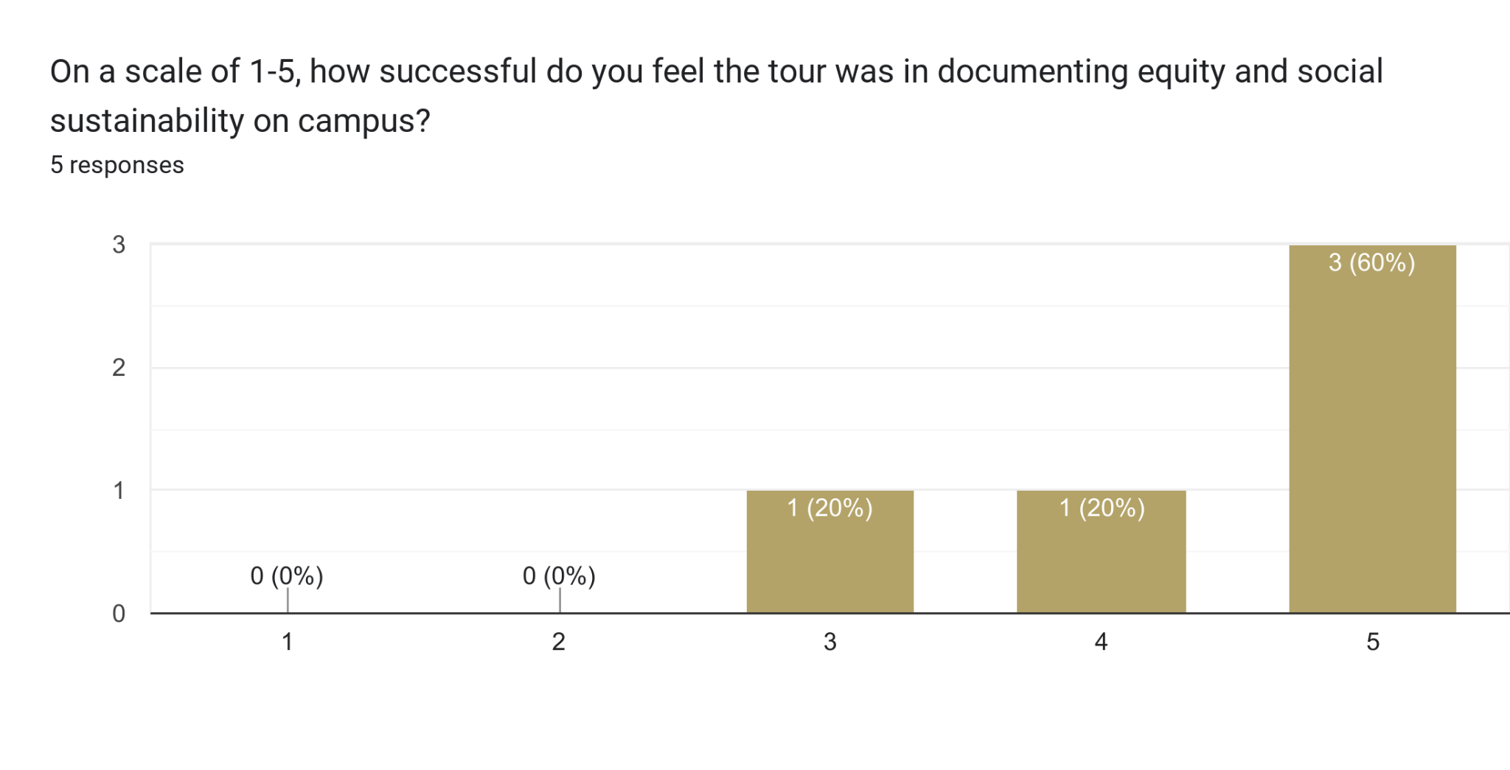

On the data chart above, the participant was asked to rate the tour based on the tour documenting on equity and sustainability on campus on a scale of 1 to 5, where one is not successful, and five is very successful. 60% of the participants think the tour information related to equity and sustainability was successful. 20% of participants believe the tour was almost successful, and 20% of participants feel that the tour is neither successful or unsuccessful.

| Are there any additional places on campus that you feel should have been included on the tour? |
| --- |
| - I like the idea of including the Techwood Homes on the tour, even though that’s really far from where we were so going there might not be feasible.  - Harrison Square is a very important site: the three first Black students and Rosa Parks have statues there.  - Statues around tech tower. |

On this question where the participants were asked about their thoughts on the additional places that must be included in the tour. The participant inputs included Techwood Homes, Harrison Square, and statues around the Tech Tower. The Techwood Homes and Harrison Square sites are important, and it was included in the previous tour guide. However, we believed because of the time limit on that day; it was impossible to go to all the sites that were included in the guide. Also, we plan to keep those sites in the future tour guide. The statues around the Tech Square site are also important, but our team does think that it would be good to get to know more if the statues around Tech Tower would help the tour overall in terms of related topics in equity and sustainability and also because the site is popular, and most visitors would know the site through the GT campus tour. This raises questions about whether the team should use the popular site and research more information on equity and sustainability or should not be included in the tour guide since there are more other sites that visitors/participants would not know about. And we will be able to help them to know more about the history as well as the equity and sustainability side on that particular site.

| Is there any additional information that you feel should have been discussed as part of the tour? |
| --- |
| - I feel like there’s use in evaluating the spaces that students frequently use like residence and dining halls, rather than just looking at campus landmarks. Additionally, one thing that I learned from the tour is that there’s a major disconnect between what students want for GT and the administrative efforts that are being made. There are real issues with the administration in this school; with how they treat students, and how little resources they put into student life, and I feel like so many people are turning a blind eye to that when transparency is really important for change.  - Including more underrepresented perspectives (like Hispanic students/Indigenous history/etc.)  - I think it's important to have multiple types of representation, including for Hispanic and Indigenous underrepresented populations.  - I think knowing more historical dates / names would have been helpful. I had to google a lot of things after the tour to get a complete picture. You should assume your audience knows nothing about the topic. |

The last question on the survey was to ask the participants about their thoughts on other additional information that should be included in the tour. We thought the participants' input on this question helped us develop a better guide. The 20% of participants rated the tour as neither successful nor unsuccessful and believed the tour should be looked at sites that the students frequently used rather than campus landmarks. However, GT already has an existing VR tour that serves to cover the frequently used areas, and the goal of our tour is to fill in the missing gap of landmarks that tell more about Georgia Tech’s culture and history. We think that this feedback is crucial in the sense that it tells us GT has done a poor job advertising its existing tour to current and prospective students, so we should focus on promoting our tour to let students know that this tour serves to fill the current gap that GT’s existing tour has left. Also other inputs are that the tour should also be including different representations. We have acknowledged this problem and are working on it by reaching out to various organizations from different representations on campus to get more information, ideas, history, etc. That would help future tour participants feel welcome.

Lastly, the tour should provide historic dates/names and information for each site so the participant can understand more. The team has acknowledged this issue and to address it in the future guide. We do not want the participants distracted by looking at their phones and looking up the information for each site. We want all participants on this tour to get all the information they need and learn about each site with equity and sustainability information. This is also why the team wants to develop a virtual/VR tour, where we can include more details on each site, facts, questions, history, dates, and names of those sites that would not make the participants feel overwhelmed. Having an audio tour function would also fix this problem to avoid long paragraphs of information. The audio would help the participant listen to the detailed information while experiencing the tour.

We are excited and believe that the team will be able to deliver our best work to help the further tour participants be delighted with the tour we will develop.

**References:**

*A Safe and Just Space for Humanity*. (n.d.). [Pdf]. Oxfam Discussion Papers. <https://www-cdn.oxfam.org/s3fs-public/file_attachments/dp-a-safe-and-just-space-for-humanity-130212-en_5.pdf>

*Georgia Tech Sustainable Campus Design*. (n.d.). <https://sustain.gatech.edu/sites/default/files/documents/overall_sustainabilitiy.pdf>

*GT Campus Sustainability—Self-Guided Campus Tours*. (n.d.). <https://sustain.gatech.edu/self-guided-campus-tours>

*GT Sustainability Website*. (n.d.). <https://news.gatech.edu/news/2021/04/22/kendeda-building-georgia-tech-earns-living-building-certification>

*THE 17 GOALS*. (n.d.). United Nations. <https://sdgs.un.org/goals>

*The Whistle*. (n.d.). <https://smartech.gatech.edu/bitstream/handle/1853/41536/1996-04-01_19_80.pdf?sequence=1>

*Writing Survey Questions*. (n.d.). Pew Research Center. <https://www.pewresearch.org/our-methods/u-s-surveys/writing-survey-questions/>